Notes on The Marsh-Bell

Michael Wild

AME notes on The Marsh-Bell.

Version 1.0.1

Fan work

Notes on Marsh-Bell 2
Dale And a SHort Jouney 2
Orcs! 3
Audience 3
Into Darkness 4
Completion 4
Monsters 6
Additional handouts 8
About the AuthoR 8

Notes on Marsh-Bell
This is a reworking of the adventure supplied The One Ring RPG book section 9 to work with AME. This is just a reworking of the material to allow its use now. This is a “fan” work and no rights are reserved. It was created to allow use of the material for AME.

Dale And a SHort Jouney
The fellowship starts near Dale. They form up when some one makes a Riddle check or other skill roll and learns that Gloin, yes one of the original member of Thorin Oakinshield’s Company, has moved to his house in Esgaroth from Eraborn and is looking for some help—preferably dwarves or maybe a few hobbits. If they are mis-rolls badly or make some “noise” about why they are headed to Esgaroth they Enemy will hear and wish to make their trip more eventful.

Note: In play we had some one roll a one so that was “noise.” The Lore Master (LM) went around the table and asked each player what their character was doing. A second round was done after all the players heard each other and skill checks were made as players tried to spot bad guys, the roll of a one had one player draw attention of The Enemy and another player saw the “spy” tell a fell looking raven that a rescue mission was forming. We went around about three times to see what they could learn. They learned that something was not quite right at Eraborn. They learned that Gloin was away. They learned that Balin and Oin were not seen of late.

Insight or other skill
You hear that “Gloin, the rich and closely connected to the King Under The Mountain is in Esgaroth on some business—Rumor is that he is looking for a company to assist him.” He is a rich dwarf and it is unlike him to head out in a hurry and to look for help.

Riddle skill
“Gloin has left for Esgoroth,” and this is unusual. He has busy on so much work to continue the reworking of the Eraborn more damaged areas. A note about work in Esgaroth for a company in dwarf runes appeared about the same time. A riddle and a story seems to be opening.

No success
There may be work in Esgorth as the dwarves seem distracted and working on stone work.

The players need to make a short and likely safe journey to Esgaroth. This will be done by journey procedure.

Orcs!
Along the way they will have an encounter with agents of the Enemy. If the fellowship made “noise” or had badly failed rolls for getting information they will find notes on the orcs that include drawing of their faces. Otherwise they will just find just a dwarf rune note that translate to a need for a good company to contact Gloin in Esgoroth--the orcs are reporting back and ran into the fellowship.

Note: The Enemy is aware that important dwarves are missing and it would be good to put a little pressure on Eraborn by losing an important dwarf or two. Also, Balin has a sense of greatness and tragedy noticed by the Enemy that means the Enemy will be pained to deal with him soon. Let him be lost and forgotten now and avoid a harsher future as this will mean a fight.

If the orcs are ambushing the fellowship (this text is OK for no surprise):
It is a trap. Orcs! Here! What are they doing here so far from their dark holes!

If the orcs are met without them tracking the fellowship:
There is only one thing that stinks worse than Orc crap, yes that smell is stronger this way. Looks orcs! What are they doing here so far from their dark holes!

Map should have a small river on it.

Note: In play the orcs attacked without surprise. This was good as we used the orcs from the rules and they good knock-out a character on one hit. For the encounter, used as many orcs as there are players characters. Half the orcs were slain before they reached the player characters, as they had initiative on them, but still it was close.

Additional: The leader of the short journey rolled that the food was bad on the trip. That was an interesting addition to the troubles. The completion of the trip allowed for a bonus on the next trip.

Audience
Once in the city they players can have an audience with Gloin. He does not like elves. They can try again for insight or riddle if they are still lost a bit. There are careful dwarf runes notices in a few taverns about a need for a brave company.

If the fellowship flops at the audience they can go still but without assistance. Gloin will hear about it and will just stroke his beard and remember how well a certain hobbit did for him years ago. He will then send boats for them and papers. If they are successful they can ask for some extra equipment and items. Healing herbs are like a good choice and maybe some “cram” for back-up food.

Note: In play the audience goes well. Boats and food and equipment are provided.

Into Darkness
Basic fellowship rolls are DC10 or DC15 if difficult.

Gloin damaged the Troll in a previous battle. Use an Ogre to have it weakened. The pool that it hides in has all the lights float in it. If a character has knowledge or skill with undead they can see the dead and face a save versus corruption. There is also some gold in the hole. Again if anyone dives for it they will save versus corruption again.

The elves in Mirkwood are spotted on a DC20.

Finding the hidden treasure is a DC20.

Used the gallows-weed to give the guide something to do. If the guide misses then they don’t see the gallows-weed in time and random folks are attacked. The players need a hit on AC15 to stop it from strangling someone. It is meant to be thematic element and not a threat.

It takes only four more days of travel to get to the marsh-dweller or four rolls for corruption. This prevent from getting overly repetitive. Assistance is given to some that do not take action. In 5E this grants another roll—the player given assistance just has to declare this (In play this was done in an American Accent, “I do declare…”).

The bell rings and a DC15 is needed to resist.

Use lizard men for marsh-men, but also undead. Used ghoul like figures. Player characters that can detect undead or evil do.

Note: In play the ogre replacement was still a bit too strong. A single hit put down each player. Maybe an orc with a few more hit points would be better! The bell affected the elf. The players rescued the elf and then discovered the basement and went right to the wine cellar as that was the only blocked door. They rescued Balin and Oin and they warned the players about the horrors. They ran away—good! Balin told them he killed one troll and wounded another one—likely the one they faced.

Completion
The players returned with Balin and Oin and faced terrible horrors. They are awarded with an item of their choice. Maybe that is a bit much—but it was a terrible story and rescuing Balin should make them well received.

Any interesting item comes from dragon horde and a save versus corruption DC15 is required, a new house rule to allow for some expense for more interesting items—roll for corruption and gain a shadow point for items from the an evil horde. Twenty gold to each—newly minted so no corruption.

Made a color copy of pictures in book and handed out as we hit that section. This really helped establish the AME feel.

Tried to play LM more like Call of Cthulhu

Monsters
These are the SRD5 creatures. Placed here for help for the LM.

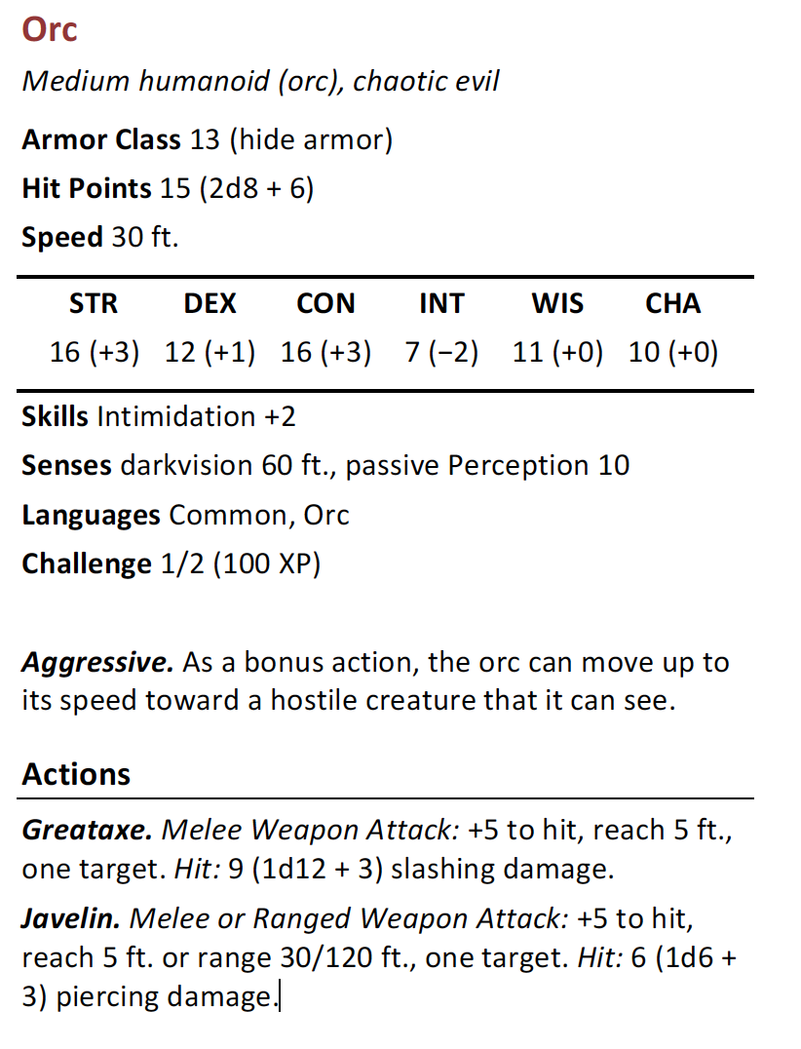

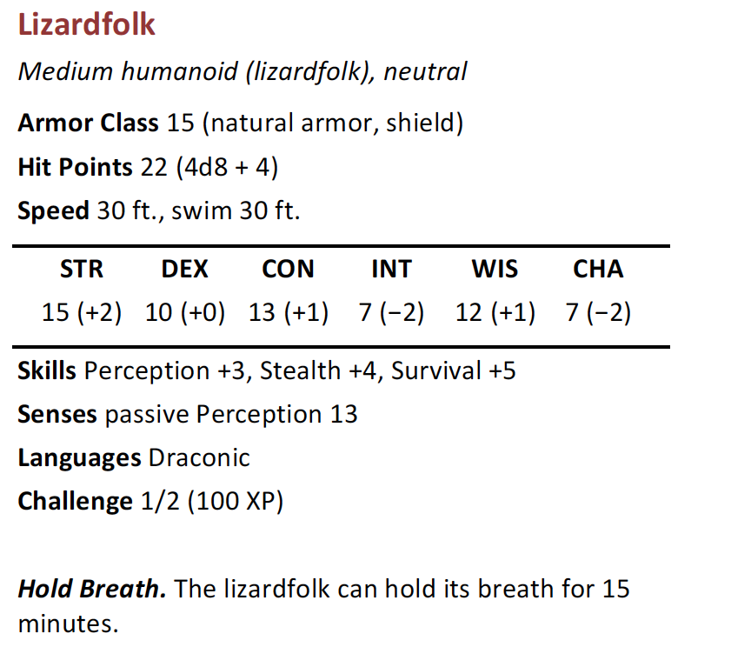

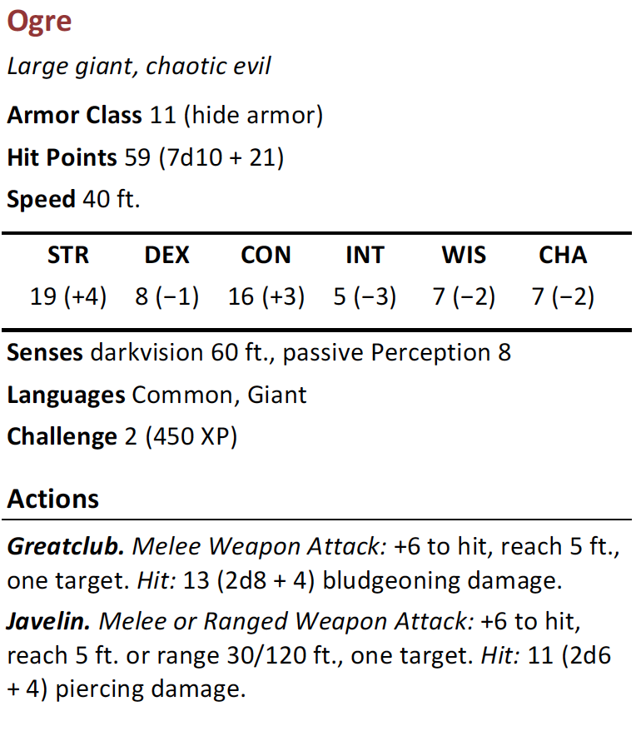

Additional handouts
Here are the additional hand-outs.

Gloin’s flyer for help:

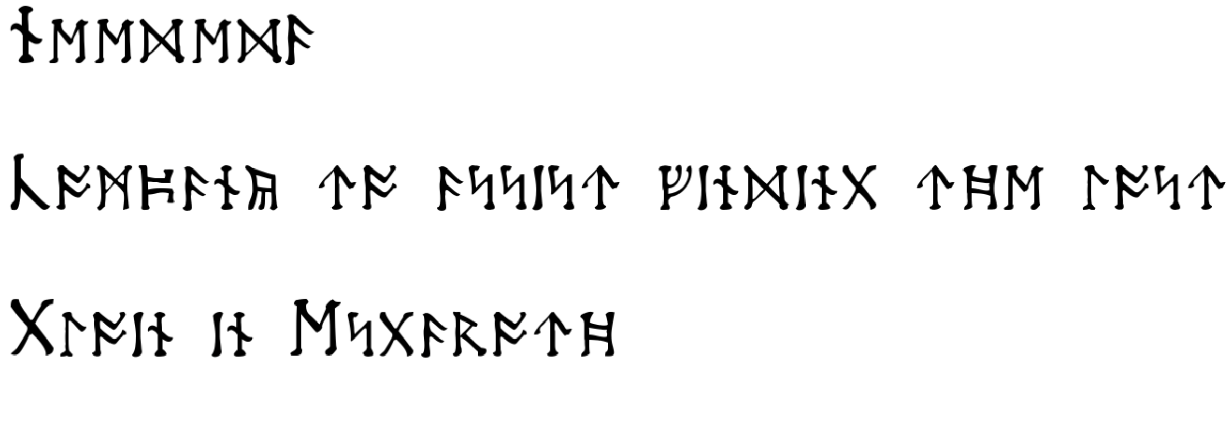
Translation:

Needed!

Company to assist finding the lost

Gloin in Esgaroth

About the AuthoR
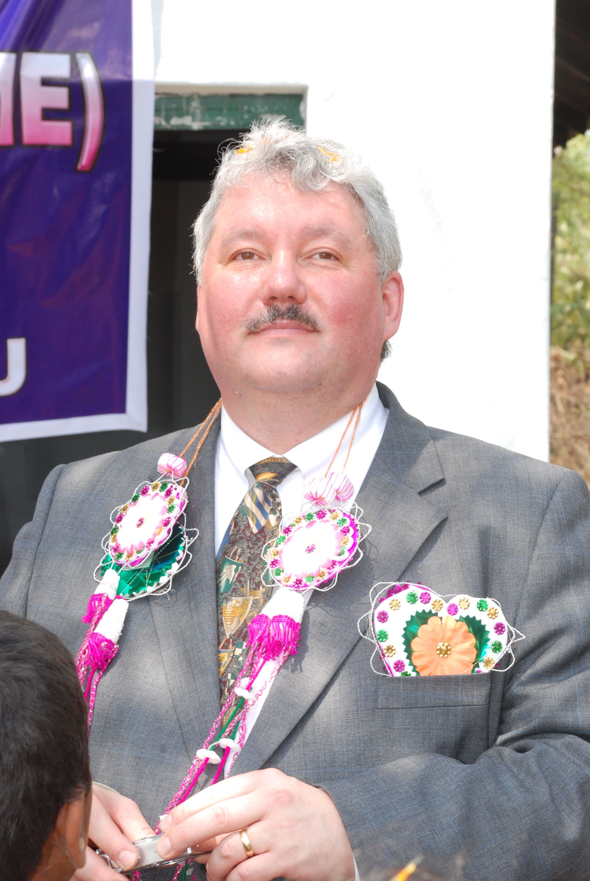
Michael R Wild is the author of many unpublished adventures. He enjoys writing his own adventures for his players. Michael played AD&D in the 1980s but stopped playing after college and did not play again until 3.0 was published. He rewrote some of his AD&D adventures for 3.0 and 3.5 and began to write a lot of 40+ page adventurers from scratch. Michael enjoys writing adventures and playing them. He played 4.0 and all of it changes for years. Michael is starting now on 5.0.

Michael resides in Aloha, Oregon since 1996 with his wife Susan and works at a local shoe company as a computer guy.

All pictures and drawings are from the author—there is nobody else to blame. He is improving his skills.

OPEN GAME LICENSE Version 1.0a

The following text is the property of Wizards of the Coast, Inc. and is Copyright 2000 Wizards of the Coast, Inc ("Wizards"). All Rights Reserved.

1. Definitions: (a)"Contributors" means the copyright and/or trademark owners who have contributed Open Game Content; (b)"Derivative Material" means copyrighted material including derivative works and translations (including into other computer languages), potation, modification, correction, addition, extension, upgrade, improvement, compilation, abridgment or other form in which an existing work may be recast, transformed or adapted; (c) "Distribute" means to reproduce, license, rent, lease, sell, broadcast, publicly display, transmit or otherwise distribute; (d)"Open Game Content" means the game mechanic and includes the methods, procedures, processes and routines to the extent such content does not embody the Product Identity and is an enhancement over the prior art and any additional content clearly identified as Open Game Content by the Contributor, and means any work covered by this License, including translations and derivative works under copyright law, but specifically excludes Product Identity. (e) "Product Identity" means product and product line names, logos and identifying marks including trade dress; artifacts; creatures characters; stories, storylines, plots, thematic elements, dialogue, incidents, language, artwork, symbols, designs, depictions, likenesses, formats, poses, concepts, themes and graphic, photographic and other visual or audio representations; names and descriptions of characters, spells, enchantments, personalities, teams, personas, likenesses and special abilities; places, locations, environments, creatures, equipment, magical or supernatural abilities or effects, logos, symbols, or graphic designs; and any other trademark or registered trademark clearly identified as Product identity by the owner of the Product Identity, and which specifically excludes the Open Game Content; (f) "Trademark" means the logos, names, mark, sign, motto, designs that are used by a Contributor to identify itself or its products or the associated products contributed to the Open Game License by the Contributor (g) "Use", "Used" or "Using" means to use, Distribute, copy, edit, format, modify, translate and otherwise create Derivative Material of Open Game Content. (h) "You" or "Your" means the licensee in terms of this agreement.

2. The License: This License applies to any Open Game Content that contains a notice indicating that the Open Game Content may only be Used under and in terms of this License. You must affix such a notice to any Open Game Content that you Use. No terms may be added to or subtracted from this License except as described by the License itself. No other terms or conditions may be applied to any Open Game Content distributed using this License.

3.Offer and Acceptance: By Using the Open Game Content You indicate Your acceptance of the terms of this License.

4. Grant and Consideration: In consideration for agreeing to use this License, the Contributors grant You a perpetual, worldwide, royalty-free, non-exclusive license with the exact terms of this License to Use, the Open Game Content.

5.Representation of Authority to Contribute: If You are contributing original material as Open Game Content, You represent that Your Contributions are Your original creation and/or You have sufficient rights to grant the rights conveyed by this License.

6.Notice of License Copyright: You must update the COPYRIGHT NOTICE portion of this License to include the exact text of the COPYRIGHT NOTICE of any Open Game Content You are copying, modifying or distributing, and You must add the title, the copyright date, and the copyright holder's name to the COPYRIGHT NOTICE of any original Open Game Content you Distribute.

7. Use of Product Identity: You agree not to Use any Product Identity, including as an indication as to compatibility, except as expressly licensed in another, independent Agreement with the owner of each element of that Product Identity. You agree not to indicate compatibility or co-adaptability with any Trademark or Registered Trademark in conjunction with a work containing Open Game Content except as expressly licensed in another, independent Agreement with the owner of such Trademark or Registered Trademark. The use of any Product Identity in Open Game Content does not constitute a challenge to the ownership of that Product Identity. The owner of any Product Identity used in Open Game Content shall retain all rights, title and interest in and to that Product Identity.

8. Identification: If you distribute Open Game Content You must clearly indicate which portions of the work that you are distributing are Open Game Content.

9. Updating the License: Wizards or its designated Agents may publish updated versions of this License. You may use any authorized version of this License to copy, modify and distribute any Open Game Content originally distributed under any version of this License.

10 Copy of this License: You MUST include a copy of this License with every copy of the Open Game Content You Distribute.

11. Use of Contributor Credits: You may not market or advertise the Open Game Content using the name of any Contributor unless You have written permission from the Contributor to do so.

12 Inability to Comply: If it is impossible for You to comply with any of the terms of this License with respect to some or all of the Open Game Content due to statute, judicial order, or governmental regulation then You may not Use any Open Game Material so affected.

13 Termination: This License will terminate automatically if You fail to comply with all terms herein and fail to cure such breach within 30 days of becoming aware of the breach. All sublicenses shall survive the termination of this License.

14 Reformation: If any provision of this License is held to be unenforceable, such provision shall be reformed only to the extent necessary to make it enforceable.

15 COPYRIGHT NOTICE
Open Game License v 1.0 Copyright 2000, Wizards of the Coast, Inc.

Runes supplied from http://derhobbit-film.de/rune_generator.shtml .

